Synopsis

**Topic:** **STAMP COLLECTION** 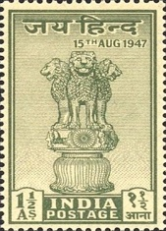

END TERM REPORT

**NAME OF THE CANDIDATE(S):**

|  |  |
| --- | --- |
| SECTION-K19PA |  |
| NAME:- | ROLL NO. |
| SIJOUSA BORO | 51 |
| JHA ANIKET SHIVANAND | 56 |
|  |  |



**DEPARTMENT OF INTELLIGENT SYSTEMS**

**SCHOOL OF COMPUTER SCIENCE AND ENGINEERING**

**LOVELY PROFESSIONAL UNIVERSITY, JALANDHAR**

**10th April-2019**

**SYNOPSIS**

**PAGES FOR THE PROJECT STAMP COLLECTION:**

* **Home Page: This project contains the basic information about the Stamp Collection.**
* **About Page: It contains all about the Stamp Collection information and their Origin.**
* **Information Page: This page contains all information about history of philatelist and their stamps photo.**
* **FAQs Page:** **The frequently asked questions section is one of the most important elements of any website.** **Some of the most common FAQ subjects are on stamp collecting, stamp supplies, stamp albums, stamp pages.**
* **Categories Page: It is the most important page in the website.It consist of 10 different countries stamp with their origin and their history behind their stamps.**

**Technology Used In The Stamp Collection:**

**We have developed this project using the below technology:**

* **HTML: Page layout has been designed in HTML.**
* **CSS: CSS has been used for all the designing part.**

**JavaScript: All the validation task and animations have been developed by JavaScript.**

**Jquery: For using Google search engine in the website.**

**Various Stamps Photo:**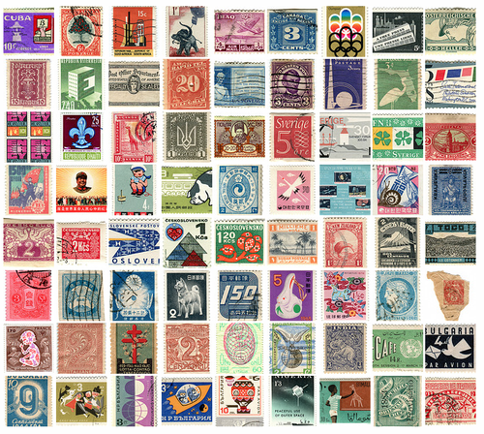

**OBJECTIVE:**

* **The objective and purpose of this Project STAMP COLLECTION website is to provide general information for visitors that may be interested in collecting stamps and to provide the specialized information needs of more advanced stamp collectors and philatelists..**

**DISTRIBUTION OF WORK AMONG THE GROUP MEMBERS:**

1. **SYNOPSIS (DONE BY SIJOUSA BORO, ROLL NO-51, REG NO-11912188)**
2. **HOME PAGE (DONE BY JHA ANIKET SHIVANAND, ROLL NO-56, REG NO-11912130)**
3. **INFORMATION PAGE: DONE BY:**

**(SIJOUSA BORO, ROLL NO-51, REG NO-11912188).**

1. **CATEGORIES PAGE:( DONE BY JHA ANIKET SHIVANAND, ROLL NO-56, REG NO-11912130)**

1. **REPORT PAGE:(DONE BY SIJOUSA BORO AND JHA ANIKET SHIVANAND)**
2. **ABOUT PAGE :(DONE BY JHA ANIKET SHIVANAND)**